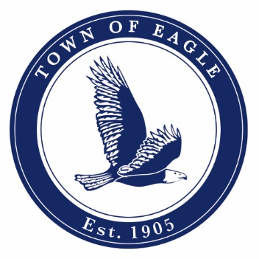

NOTICE OF PUBLIC HEARING
(Pursuant to 29-1-106, C.R.S.)

NOTICE is hereby given that a proposed budget has been submitted to the Eagle Town Council for the ensuing year of 2026 and a proposed supplemental budget amendment to amend the 2025 Town of Eagle budget; a copy of such proposed budgets have been filed in the office of Town Clerk, where the same is open for public inspection; such proposed Town of Eagle budgets will be considered at the following regular meetings of the Town Council to be held at 200 Broadway, Eagle on Tuesday, October 14, October 28 and, November 12, 2025, at 6:00 p.m.
Any interested elector of the Town of Eagle may inspect the proposed budget and file or register any objections thereto at any time prior to the final adoption of the budget, currently scheduled for November 12, 2025.
Written comments may be submitted to the Town Manager prior to the Public Hearing at larry.pardee@townofeagle.org or testimony may be given at the Public Hearing.
By Camille Deering, Town Clerk
PUBLISHED: Vail Daily: October 7, 2025 & November 5, 2025

